**LAB 01:**

Name : M Hasnain Siddiqui Roll no: 24K-0516 Date:20-jan-2025

**Question 1:**

Source code:

#include<iostream>

using namespace std;

void is_prime(int num){

    int depender=1;

     for(int i=2;i<num;i++){

    depender=depender*(num%i);

    }

    if (depender==0)

    printf("not prime");

    else

    printf("prime");

}

int main(){

    int a;

    cout<<"Enter the number";

    cin>>a;

    is_prime(a);

}

Output:

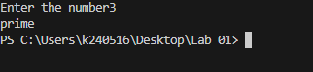

**Question 2:**

Source code:

#include<iostream>

using namespace std;

int main(){

    int n;

    cout<<"Enter the number of students: ";

    cin>>n;

int **arr= new int* [n];

for(int i=0;i<n;i++){

    arr[i]=new int [3];

}

float *average= new float[n];

    for(int j=0;j<n;j++){

        int sum =0;

        cout<<"Enter the Details for Student "<<j+1<<" "<<endl;

        cout<<"Enter the marks"<<endl;

        for(int i=0;i<3;i++){

        cout<<"Marks "<<i+1<<": ";

        cin>>arr[j][i];

        sum = sum+arr[j][i];

    }

    average[j]=sum/3;

    }

    for(int i=0;i<n;i++){

    cout<<"Details of student "<<i+1<<" "<<endl;

    for(int j=0;j<3;j++){

        cout<<"Marks "<<j+1<<" : "<<arr[i][j]<<endl;

    }

    cout<<"Average: "<<average[i]<<endl;

    if(average[i]>=90) cout<<"Grade: A"<<endl;

    else if(average[i]>=80 && average[i]<=89) cout<<"Grade: B"<<endl;

    else if(average[i]>=70 && average[i]<=79) cout<<"Grade: C"<<endl;

    else if(average[i]>=60 && average[i]<=69) cout<<"Grade: D"<<endl;

    else  cout<<"Grade: F"<<endl;

    }

   for(int i=0;i<n;i++){

    delete[] arr[i];

   }

  delete[] arr;

    }

Output:

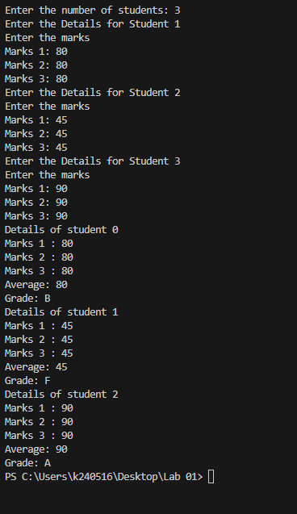

**Question 3:**

Source code:

#include<iostream>

using namespace std;

int main (){

int n,target;

    cout<<"Enter the number of elements in array: ";

    cin>>n;

    cout<<"ENter the target : ";

    cin>>target;

    int *arr= new int [n];

    for(int i=0;i<n;i++){

        cout<<"Element "<<i+1<<" :";

        cin>>arr[i];

    }

    for(int i=0;i<n;i++){

        for(int j=i+1;j<n;j++){

            if(arr[i]+arr[j]==target)

            {

                cout<<"["<<i<<","<<j<<"] "<<endl;

                cout<<"nums["<<i<<"] + nums["<<j<<"] == "<<target<<endl;

            }

        }

    }

}

Output:

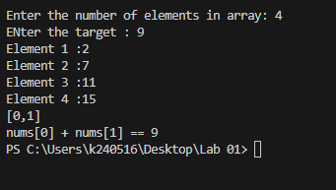

**Question 4:**

Source code:

#include <iostream>

#include <algorithm>

using namespace std;

int main()

{

    int n, i = 0;

    cout << "Enter the no of heights array you want: ";

    cin >> n;

    int j = n - 1;

    int *height = new int[n];

    for (int i = 0; i < n; i++)

    {

        cout << "Enter Height " << i + 1 << " : ";

        cin >> height[i];

    }

    int area;

    int max = 0;

    while (i < j)

    {

        area = min(height[i], height[j]) * (j - i);

        if (area > max)

        {

            max = area;

        }

        if (height[i] > height[j])

            j--;

        else

            i++;

    }

    cout << "\n"<< max << endl;

    delete[] height;

}

Output:

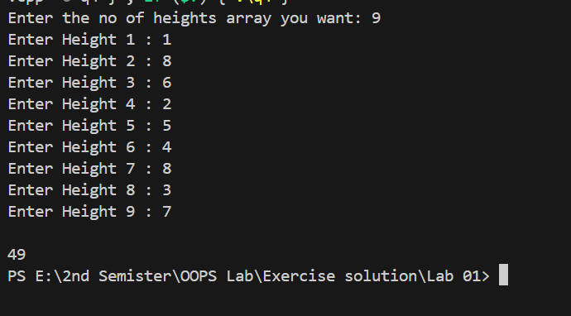

**Question 5:**

Source code:

#include <iostream>

#include <cstdlib>

using namespace std;

struct Event

{

    string name;

    string date;

    string venue;

    string organizer;

};

void inputEvents(Event *event, int num)

{

    cout << "-----Enter Details for the Events-----" << endl;

    for (int i = 0; i < num; i++)

    {

        cout << "           Event " << i + 1 << "          " << endl;

        cout << "Name: ";

        cin >> event[i].name;

        cout << "Date(i.e 20/05/2025): ";

        cin >> event[i].date;

        cout << "Venue: ";

        cin >> event[i].venue;

        cout << "Organizer: ";

        cin >> event[i].organizer;

    }

}

void displayEvents(Event *event, int num)

{

    cout << "\n--------All Events Details---------" << endl;

    for (int i = 0; i < num; i++)

    {

        cout << "-----------Event " << i + 1 << " ---------" << endl;

        cout << "Name: " << event[i].name << endl;

        cout << "Date: " << event[i].date << endl;

        cout << "Venue: " << event[i].venue << endl;

        cout << "Organizer: " << event[i].organizer << endl;

    }

}

void SearchEvent(Event *event, int num)

{

    string serachdate;

    int flag = 1;

    cout << "Enter Date(i.e 20/05/2025): ";

    cin >> serachdate;

    for (int i = 0; i < num; i++)

    {

        if (event[i].date == serachdate)

        {

            cout << "-----------Event " << i + 1 << " ---------" << endl;

            cout << "Name: " << event[i].name << endl;

            cout << "Venue: " << event[i].venue << endl;

            cout << "Organizer: " << event[i].organizer << endl;

            flag = 0;

        }

    }

    if (flag == 1)

        cout << "\nSorry No such event found" << endl;

}

int main()

{

    int num;

    cout << "Enter the number of events : ";

    cin >> num;

    Event *event = new Event[num];

    inputEvents(event, num);

    displayEvents(event, num);

    cout << "\nNow you can search any event you enter by date" << endl;

    SearchEvent(event, num);

    delete[] event;

}

Output:

